Exercise
Problem Statement: There can be multiple customers, who can place multiple orders on the site. Now a sales person can handle these orders will distribute into multiple sales persons (One order will be assign to one salesperson only). So a sales person can have multiple orders of multiple customers
- Create Database

Command:
create database myexercise_db;
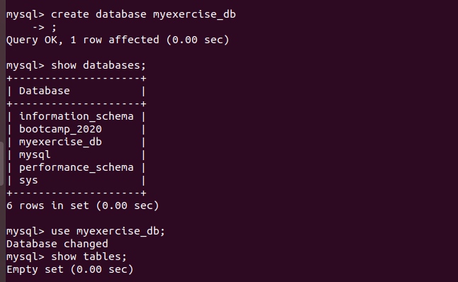

- Design Schema

Command:
create schema myexercise;
show schemas;



- Create tables

Command:

create table mycustomer
(
custid int PRIMARY KEY NOT NULL,
cname varchar(100)
)



---------------------------------------------------------------------------------------------
create table mysalesman
(
salesid int PRIMARY KEY NOT NULL,
sname varchar(100)
)


----------------------------------------------------------------------------------------------

create table myorders
(
orderid int,
PRIMARY KEY(orderid),
cid int,
sid int,
FOREIGN KEY (cid) REFERENCES mycustomer (custid),
FOREIGN KEY (sid) REFERENCES mysalesman (salesid)
)

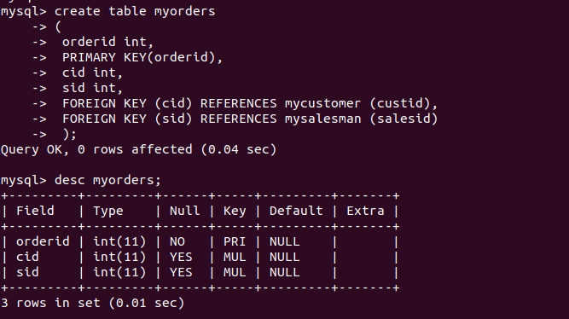

- Insert sample data

Command:

insert into mycustomer values (101,'ram');
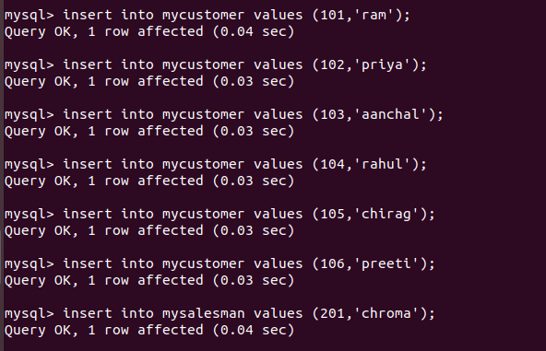

mysalesman
insert into mysalesman values (201,'chroma');

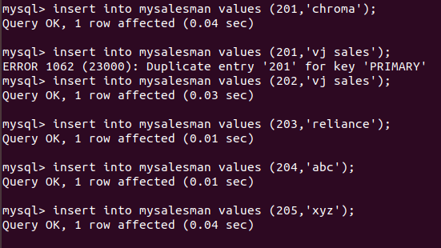

insert into myorders values (201,101,201);

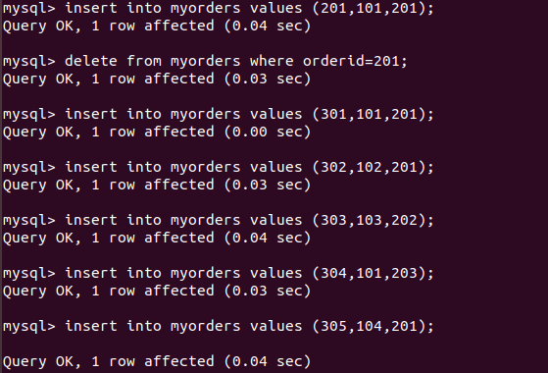

Print all data

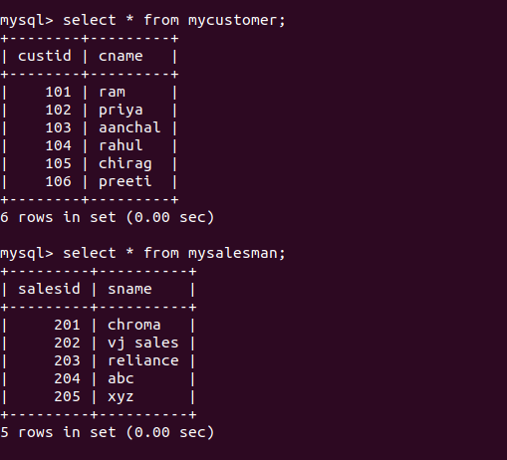

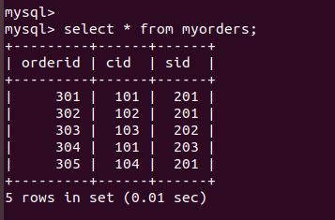

- Find the sales person have multiple orders.

Command:

select * from mysalesman
where salesid in (select sid from myorders group by sid having count(sid)>=1);

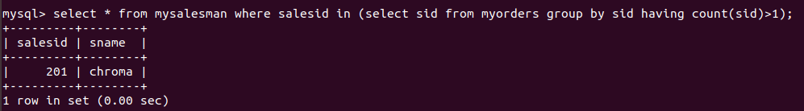

- Find the all sales person details along with order details

Command:

select s.salesid,s.sname,m.orderid,m.sid from mysalesman s, myorders m
where s.salesid=m.sid;
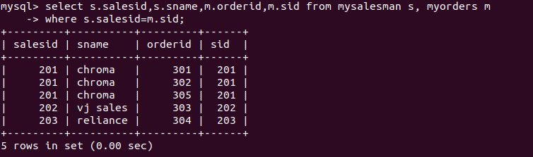

- Create index

Command:
Here I am creating index on mycustomer table on custid column.

For Create Index
create index custindex
on mycustomer (custid);

Showing Index
show index from mycustomer;
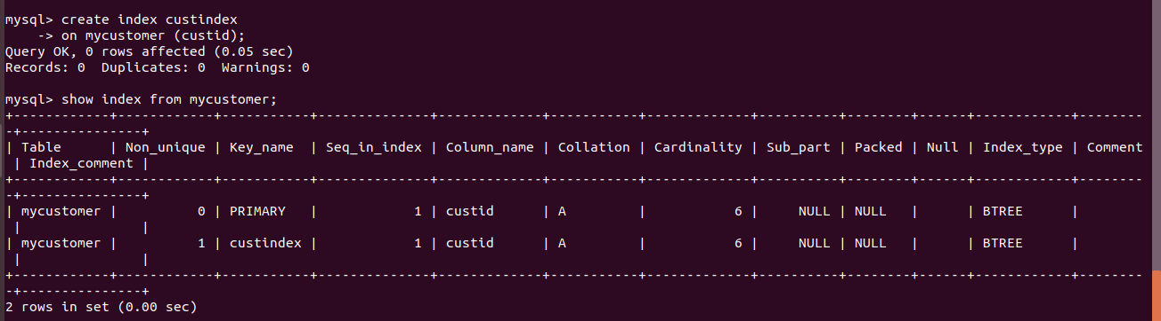

- How to show index on a table

Command:

Showing Index
show index from mycustomer;

- Find the order number, sale person name, along with the customer to whom that order belongs to
Command:

select c.custid,c.cname,s.salesid,s.sname,m.orderid from mycustomer c,mysalesman s, myorders m
where s.salesid=m.sid AND c.custid=m.cid;

